**Lab 1**: Design a single form that checks the validity of user login form. Assume that data is already in the DB. Use Client Side Validation to check empty values in form

Source Code

<!DOCTYPE html>

<html>

<head>

<title>Login Page</title>

<style type="text/css">

.login_form_container{

margin-left: 560px;

margin-top: 160px;

margin-right: 580px;

padding: 30px;

border: 10px darkgray double;

border-radius: 20px;

}

.login_heading{

text-align: center;

font-size: 30px;

font-weight: 50px;

}

.email-label-margin{

margin-right: 40px;

}

.password-label-margin{

margin-right: 10px;

}

.login-button{

text-align: center;

background: antiquewhite;

margin-left: 110px;

margin-top: 20px;

padding: 10px 25px 7px 25px;

border-radius: 20px;

}

.danger{

font-size: 10px;

text-align: center;

color: #ff0000;

}

</style>

</head>

<body>

<div class="login_form_container">

<form class="login_form">

<legend class="login_heading">Login Form</legend>

<div>

<label class="email-label-margin">Email</label>

<input type="email" id="email" name="email" placeholder="Enter Email Address">

<br>

<span class="danger" id="email-validation"></span>

</div>

<div>

<label class="password-label-margin">Password</label>

<input type="password" id="password" name="password" placeholder="Enter Password">

<br>

<span class="danger" id="password-validation"></span>

</div>

<button class="login-button" type="button" onclick="submitAction()">Login</button>

</form>

</div>

</body>

<script type="text/javascript">

function submitAction() {

var email = document.getElementById('email').value;

if(email == '')

{

document.getElementById('email-validation').innerHTML = "Please Enter Email Address";

}

var password = document.getElementById('password').value;

if(password == '')

{

document.getElementById('password-validation').innerHTML = "Please Enter Password Field";

}

}

</script>

</html>

Output

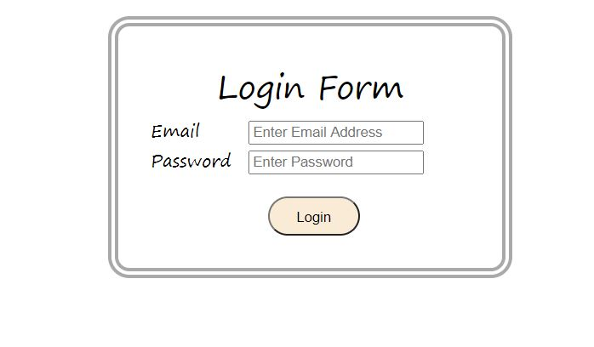

After Clicking Login Button

